Mini Project
Netflix Movies and TV Shows - Exploratory Data Analysis Report
Data Science Summer Training | Prepared by: Vishal Sharma
Dataset Records | 7787 rows | Dataset Columns | 12 columns
Movies | 5377 (69.05%) | TV Shows | 2410 (30.95%)
Top Country | United States (3296 titles) | Top Genre | International Movies
Most Common Rating | TV-MA (2870 titles) | Peak Release Year | 2018 (1121 titles)

Executive Summary
- The dataset contains 7787 Netflix titles with 12 columns covering type, title, director, cast, country, release year, rating, duration, genre and description.
- Movies dominate the catalogue with 5377 titles, which is 69.05% of total content.
- TV Shows account for 2410 titles, which is 30.95% of total content.
- The strongest production region is United States, followed by India and the United Kingdom.
- The most common maturity rating is TV-MA, and the most frequent genre category is International Movies.

Task 1: Dataset Understanding
Rows | 7787 | Columns | 12
Duplicate Rows | 0 | Release Year Range | 1925 to 2021
Movie Records | 5377 | TV Show Records | 2410

Column Name | Data Type
show_id | object
type | object
title | object
director | object
cast | object
country | object
date_added | object
release_year | int64
rating | object
duration | int64
genres | object
description | object

Interpretation: The dataset has a good structure for EDA because it includes categorical variables such as type, country, rating and genres, along with numerical/time variables such as release_year and duration.

Task 2: Data Cleaning
Category | Missing Before Cleaning | Missing After Cleaning
cast | 718.00 | 0
country | 507.00 | 0
date_added | 10.00 | 98
description | 0.00 | 0
director | 2389.00 | 0
duration | 0.00 | 0
duration_num | nan | 0
genres | 0.00 | 0
rating | 7.00 | 0
release_year | 0.00 | 0
show_id | 0.00 | 0
title | 0.00 | 0
type | 0.00 | 0

- Duplicate rows were checked and removed if present. No duplicate rows remained after cleaning.
- Missing director, cast and country values were filled with Unknown.
- Missing rating values were filled using the mode rating.
- date_added was converted into a proper datetime column; invalid or unknown dates were kept as missing dates.
- duration was converted into numeric duration_num for duration and outlier analysis.

Task 3: Content Type Analysis
type | Count | Percentage (%)
Movie | 5377 | 69.05
TV Show | 2410 | 30.95

Answer: There are 5377 Movies and 2410 TV Shows. Movies contribute 69.05% and TV Shows contribute 30.95%.
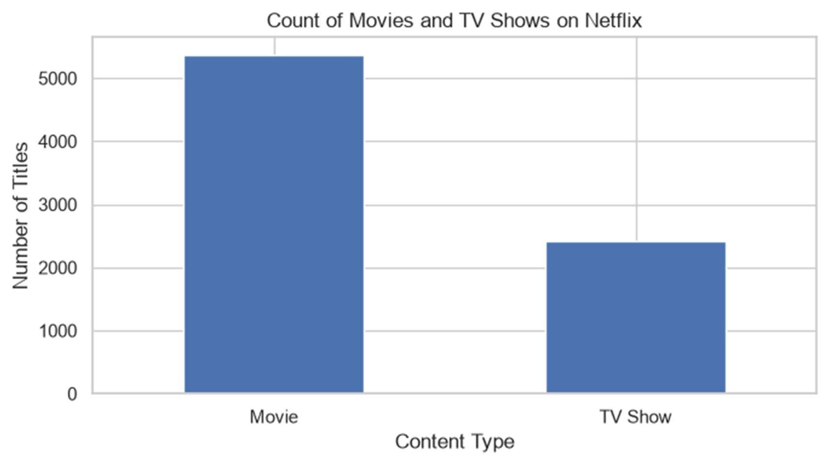
Figure 1: Count plot of Movies and TV Shows
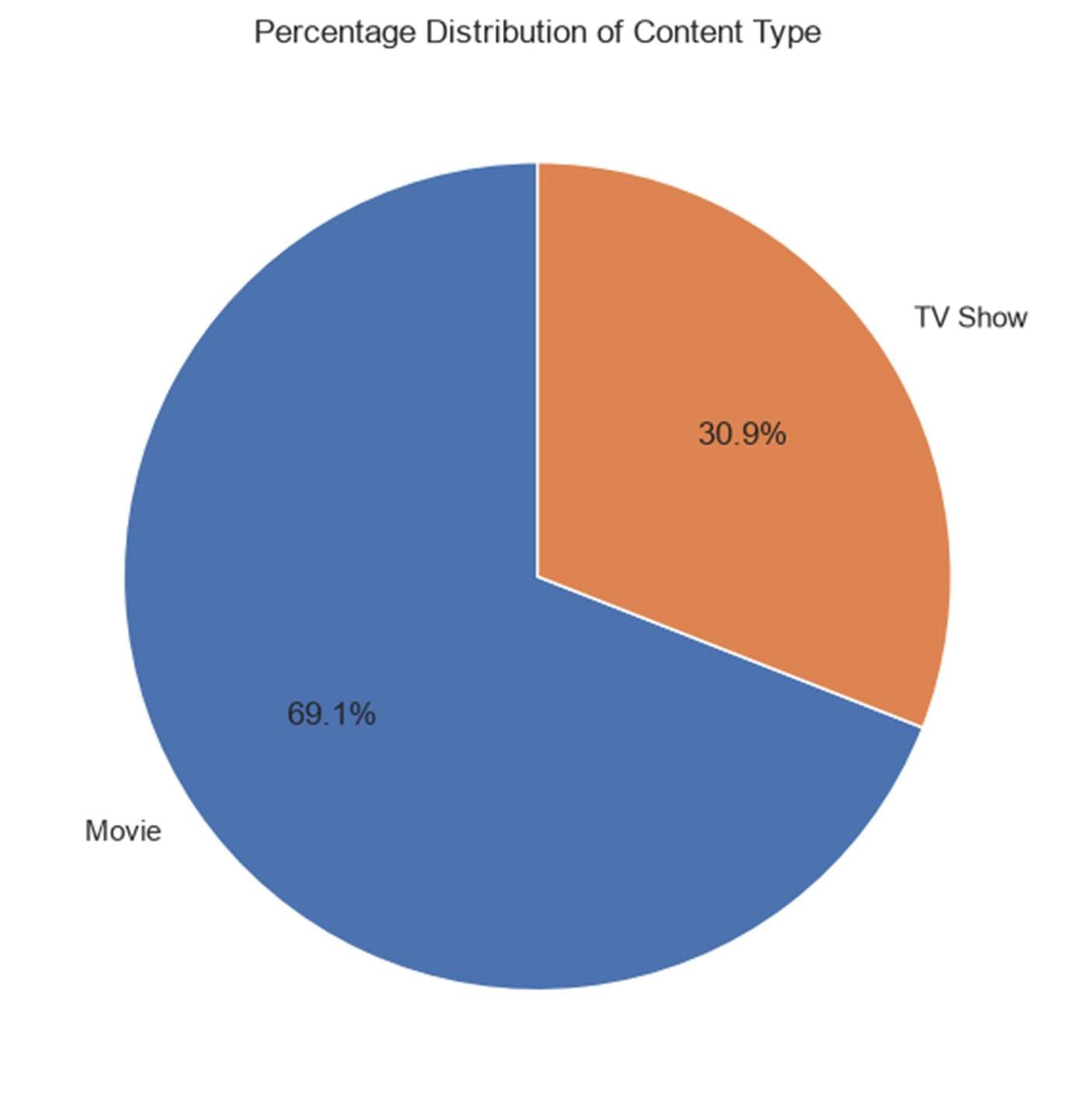
Figure 2: Percentage distribution of content type

Task 4: Country Analysis
country | Number of Titles
United States | 3296
India | 990
United Kingdom | 722
Canada | 412
France | 349
Japan | 287
Spain | 215
South Korea | 212
Germany | 199
Mexico | 154

Answer: United States produces the highest number of titles (3296), followed by India and United Kingdom.
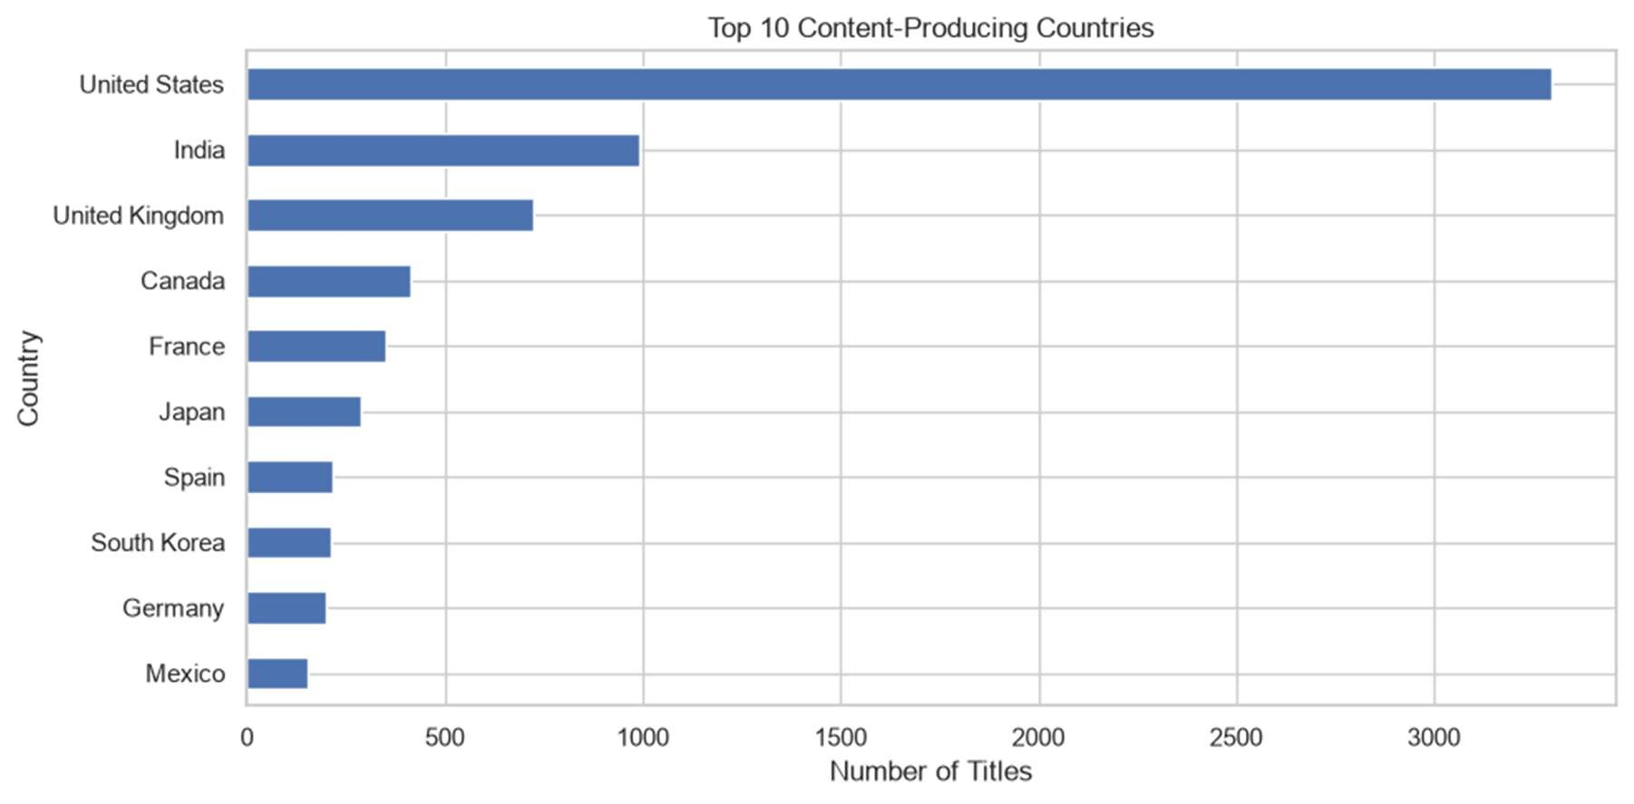
Figure 3: Top 10 content-producing countries

Task 5: Yearly Trend Analysis
release_year | Number of Titles
2002 | 45
2003 | 49
2004 | 59
2005 | 73
2006 | 85
2007 | 85
2008 | 125
2009 | 137
2010 | 173
2011 | 166
2012 | 219
2013 | 267
2014 | 334
2015 | 541
2016 | 882
2017 | 1012
2018 | 1121
2019 | 996
2020 | 868
2021 | 31

- The peak release year is 2018, with 1121 titles in this dataset.
- Content production increased strongly from the early 2000s to the late 2010s.
- The drop in 2021 should be interpreted carefully because the dataset may not include the complete year.
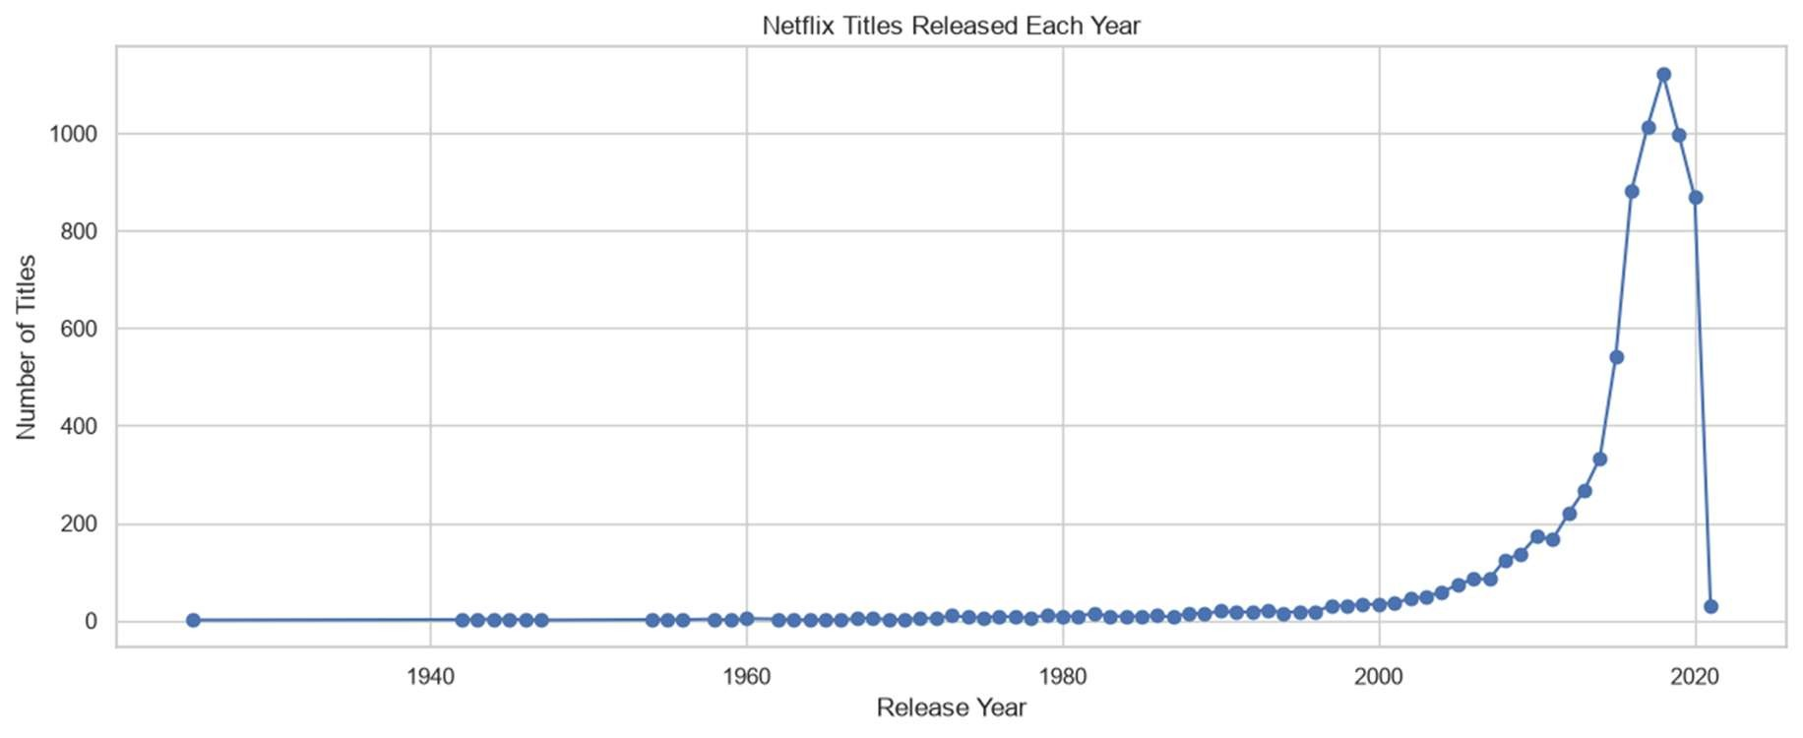
Figure 4: Yearly trend of Netflix titles released
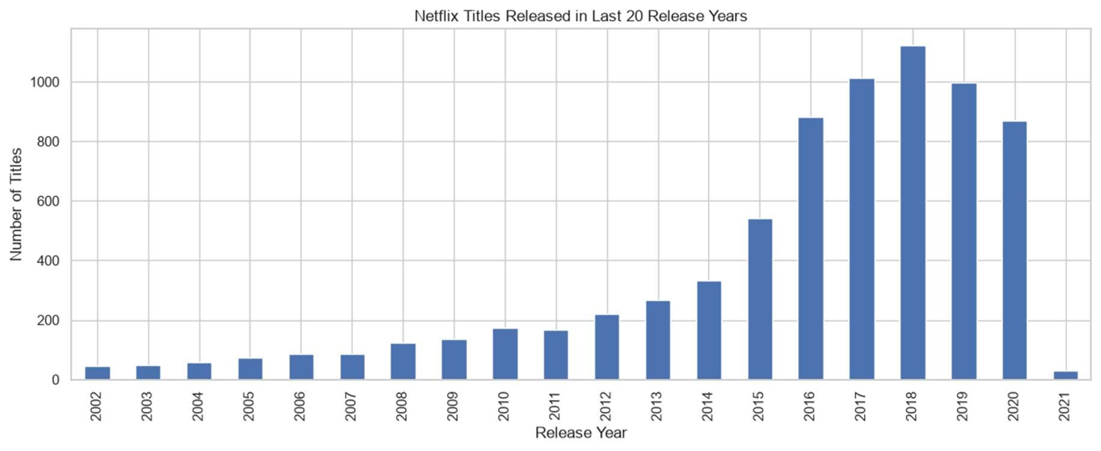
Figure 5: Netflix titles released in the last 20 release years

Task 6: Rating Analysis
rating | Number of Titles
TV-MA | 2870
TV-14 | 1931
TV-PG | 806
R | 665
PG-13 | 386
TV-Y | 280
TV-Y7 | 271
PG | 247
TV-G | 194
NR | 84
G | 39
TV-Y7-FV | 6
UR | 5
NC-17 | 3

Answer: The most common maturity rating is TV-MA, with 2870 titles.
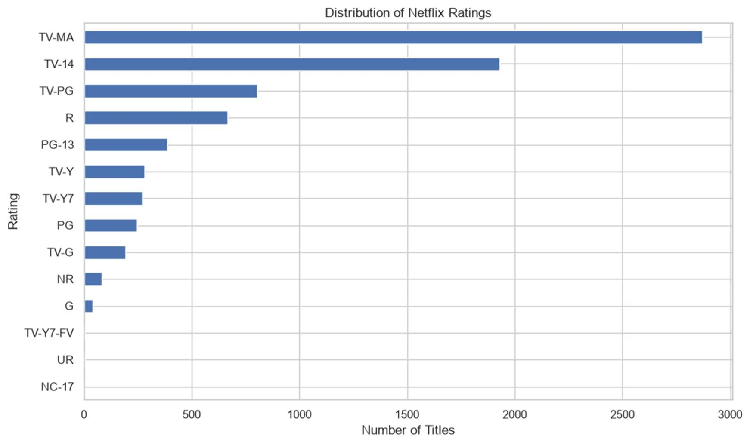
Figure 6: Distribution of Netflix maturity ratings

Task 7: Genre Analysis
genres | Number of Titles
International Movies | 2437
Dramas | 2106
Comedies | 1471
International TV Shows | 1199
Documentaries | 786
Action & Adventure | 721
TV Dramas | 704
Independent Movies | 673
Children & Family Movies | 532
Romantic Movies | 531

Answer: The most popular genre category is International Movies, with 2437 titles.
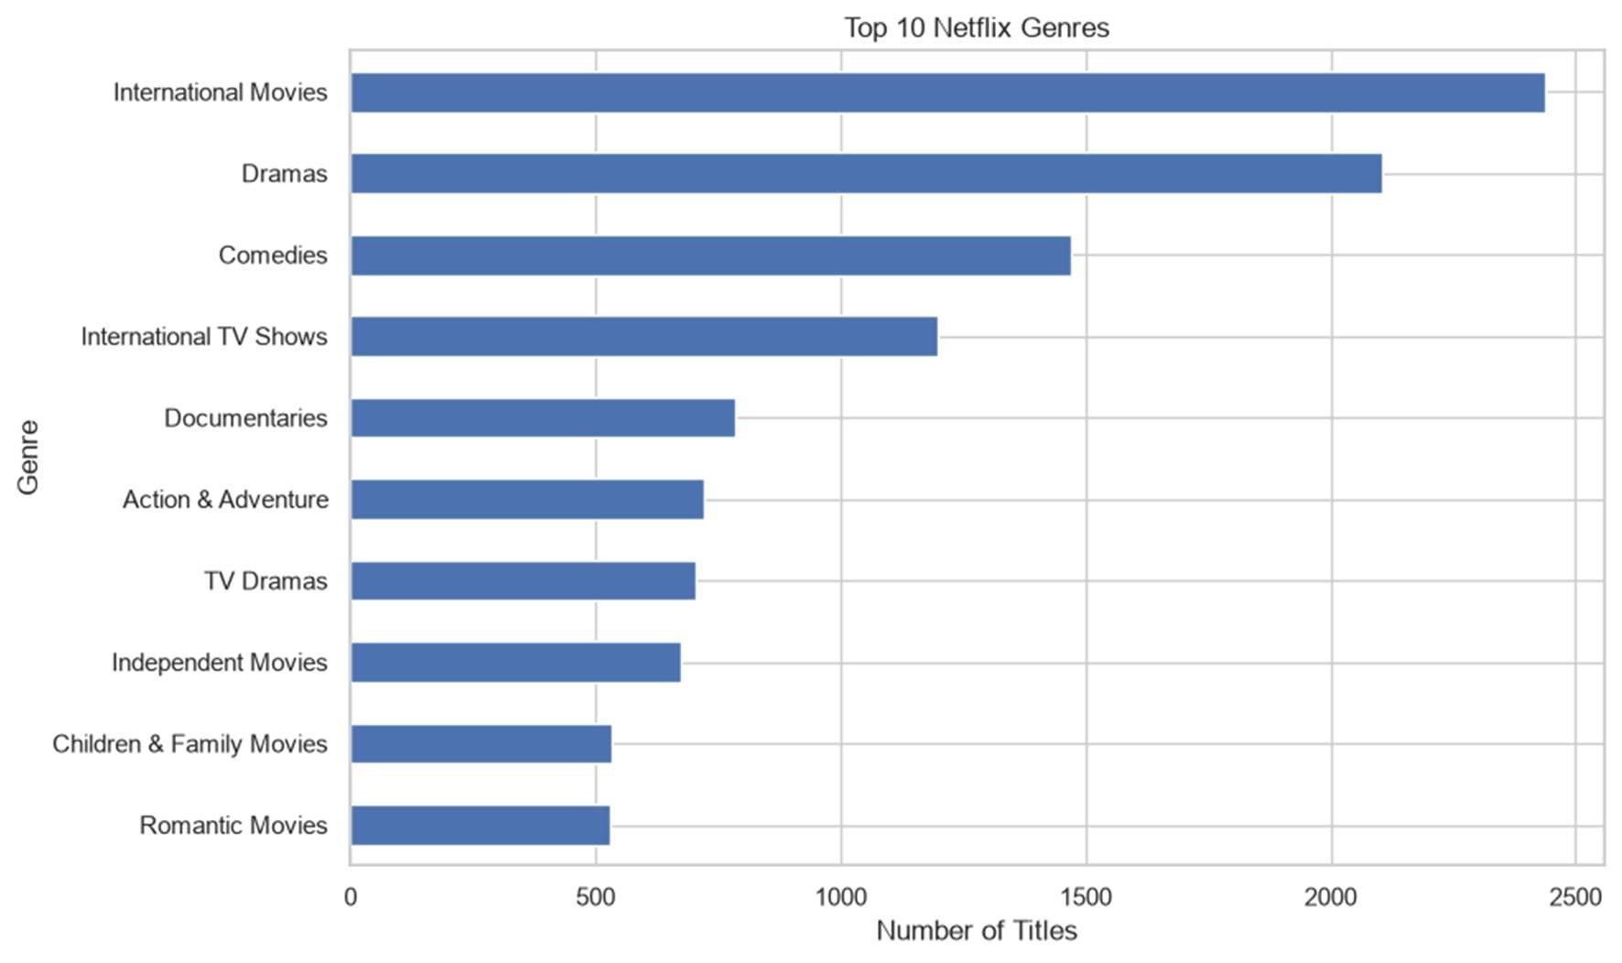
Figure 7: Top 10 Netflix genres

Task 8: Duration Analysis
Average Movie Duration | 99.31 minutes
Longest Movie | Black Mirror: Bandersnatch (312 min)
Shortest Movie | Silent (3 min)
Movies Analyzed | 5377

- Most movies are concentrated around medium runtime values.
- The histogram shows that Netflix movie durations mostly fall near the 80-120 minute range.
- The box plot shows several very long duration values that behave as outliers.
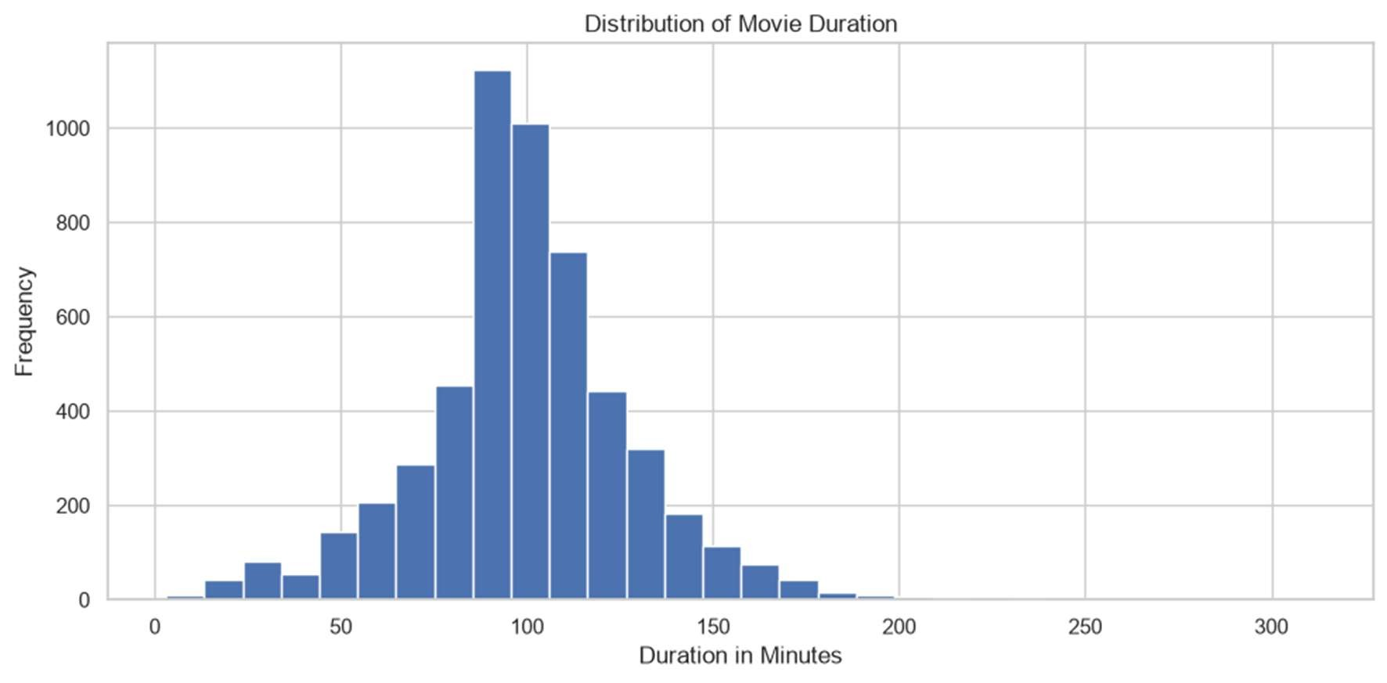
Figure 8: Distribution of movie duration
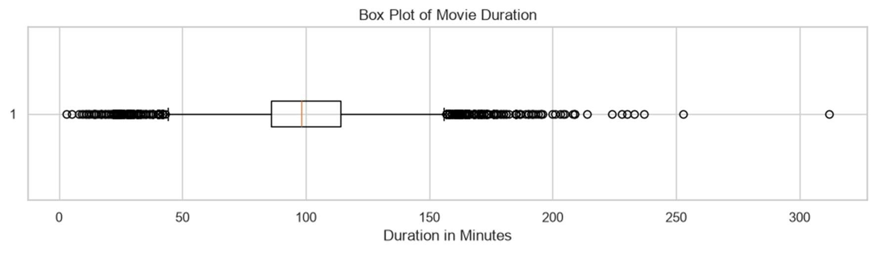
Figure 9: Box plot of movie duration

Task 9: Outlier Analysis
Method | Rule Used | Outlier Count
IQR | Outside 44 to 156 minutes | 337
Z-score | |Z-score| > 3 | 45

Q1 | 86 min | Q3 | 114 min
IQR | 28 min | Lower Bound | 44 min
Upper Bound | 156 min

Movie Title | Duration (min)
Black Mirror: Bandersnatch | 312
The School of Mischief | 253
No Longer kids | 237
Lock Your Girls In | 233
Raya and Sakina | 230
Sangam | 228
Lagaan | 224
Jodhaa Akbar | 214
Kabhi Khushi Kabhie Gham | 209
The Irishman | 209

- IQR detected 337 outliers, while Z-score detected 45 outliers.
- IQR is more sensitive here because it uses quartile boundaries and detects both very short and very long movies.
- Z-score is stricter and mainly captures extremely long movies far from the mean.

Task 10: Feature Engineering
release_decade | Number of Titles
1920s | 1
1940s | 14
1950s | 11
1960s | 25
1970s | 67
1980s | 106
1990s | 225
2000s | 728
2010s | 5711
2020s | 899

Average Content Age | 12.07 years | Median Content Age | 9 years
Newest Content Age | 5 years | Oldest Content Age | 101 years

duration_category | Number of Movies
Short | 446
Medium | 3920
Long | 1011

- Release decade groups titles into decade-level categories such as 1980s, 1990s, 2000s, 2010s and 2020s.
- Content age was calculated as 2026 minus release_year.
- Movie duration category was divided into Short, Medium and Long, where Medium movies dominate the catalogue.
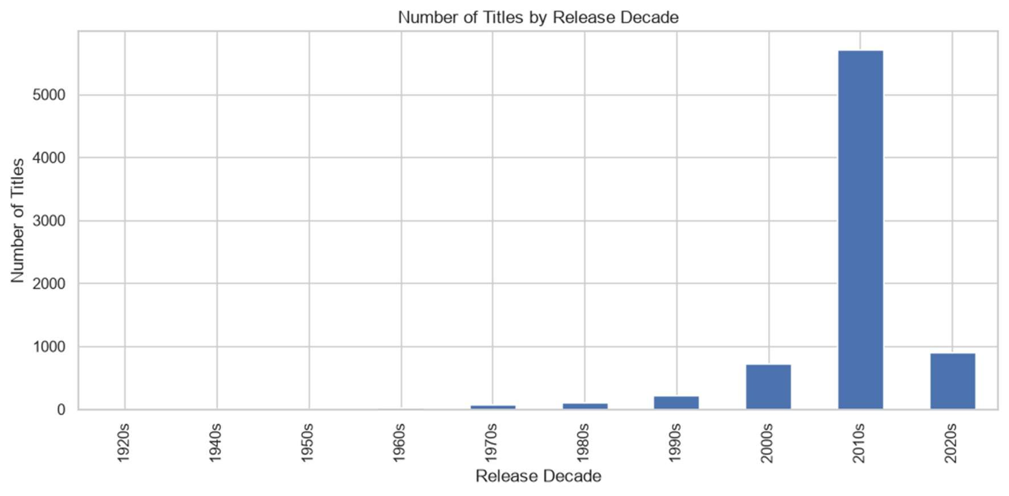
Figure 10: Number of titles by release decade
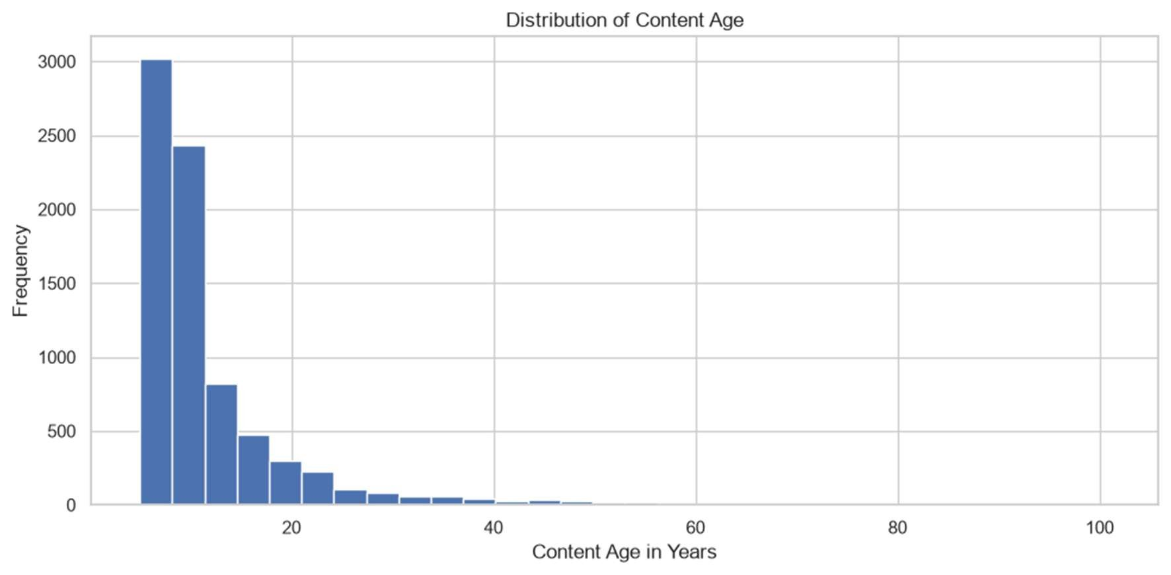
Figure 11: Distribution of content age
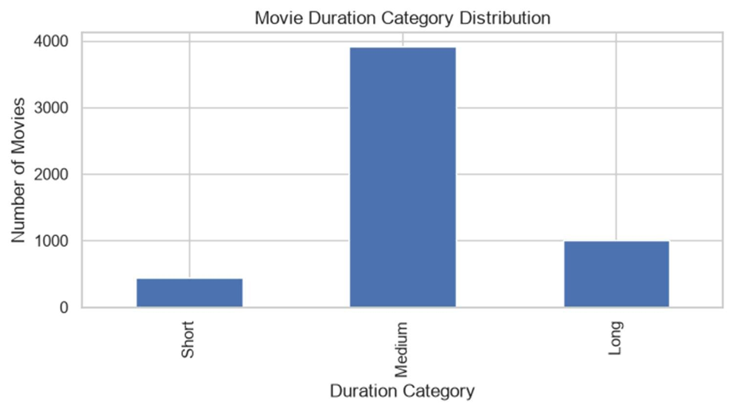
Figure 12: Movie duration category distribution

Task 11: Multivariate Analysis

Country vs Content Type
country | Movie | TV Show
United States | 2430 | 866
India | 915 | 75
United Kingdom | 466 | 256
Canada | 286 | 126
France | 265 | 84
Japan | 103 | 184
Spain | 158 | 57
South Korea | 55 | 157
Germany | 157 | 42
Mexico | 101 | 53

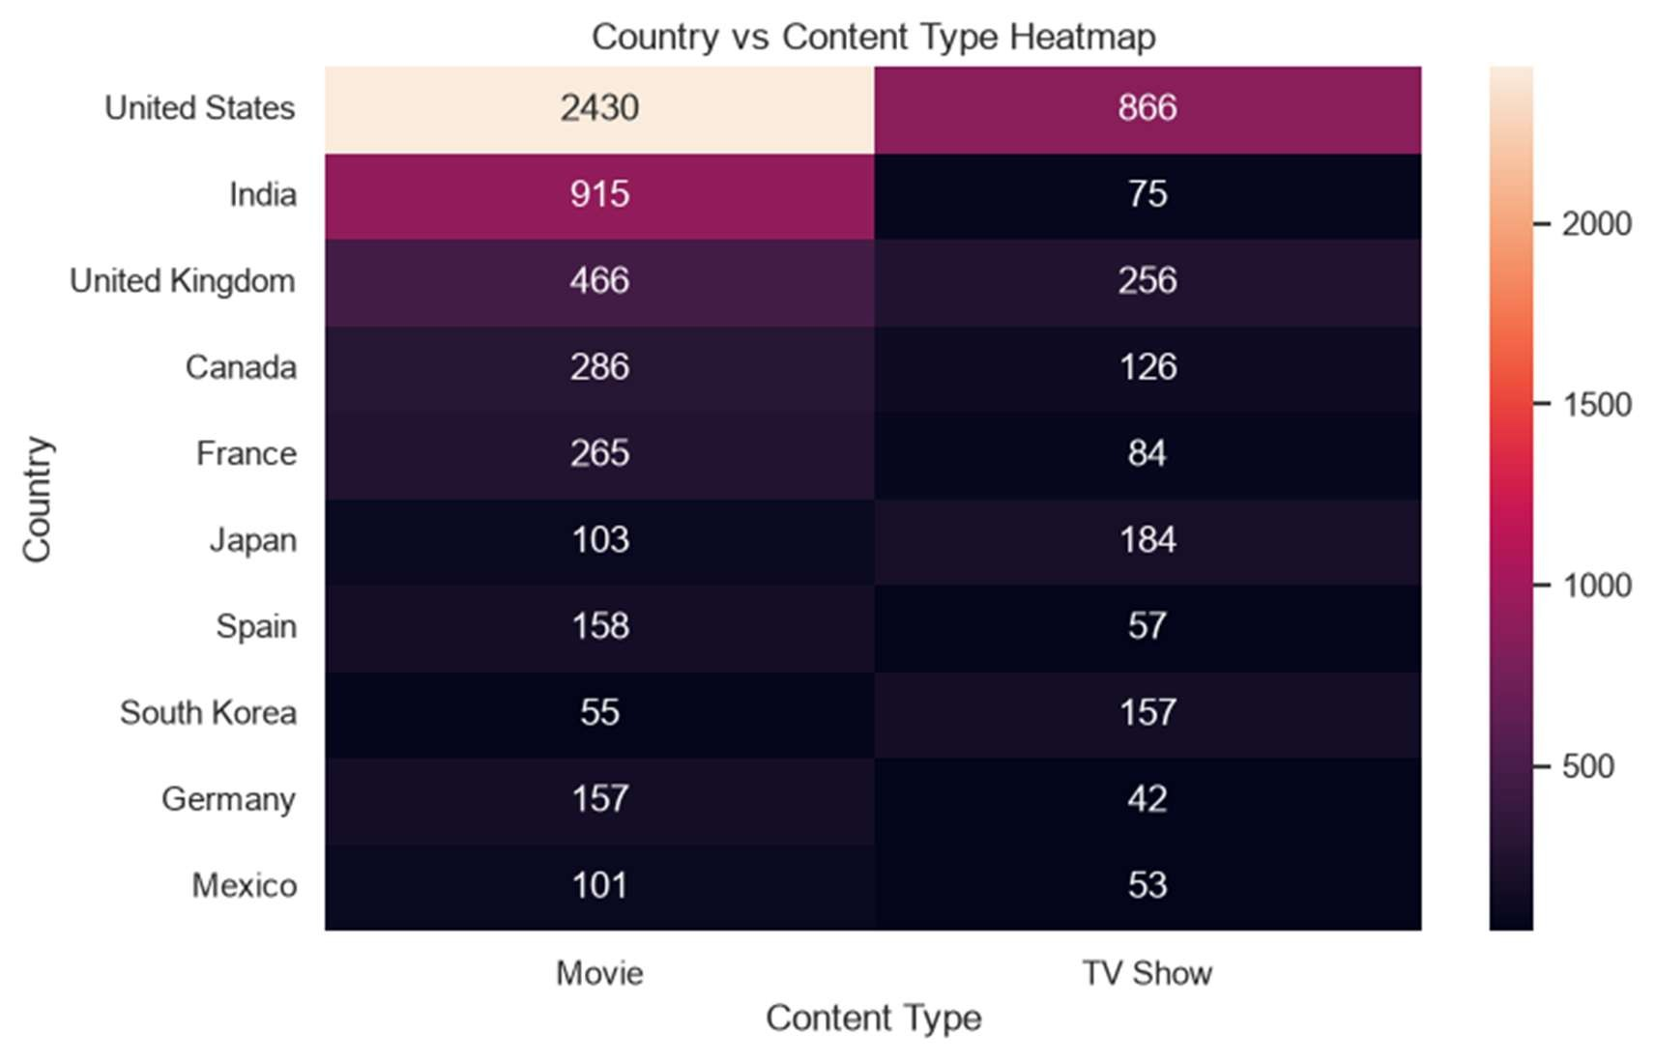
Figure 13: Country vs content type heatmap

Year vs Content Type
release_year | Movie | TV Show
2012 | 158 | 61
2013 | 202 | 65
2014 | 244 | 90
2015 | 382 | 159
2016 | 642 | 240
2017 | 744 | 268
2018 | 734 | 387
2019 | 582 | 414
2020 | 411 | 457
2021 | 12 | 19

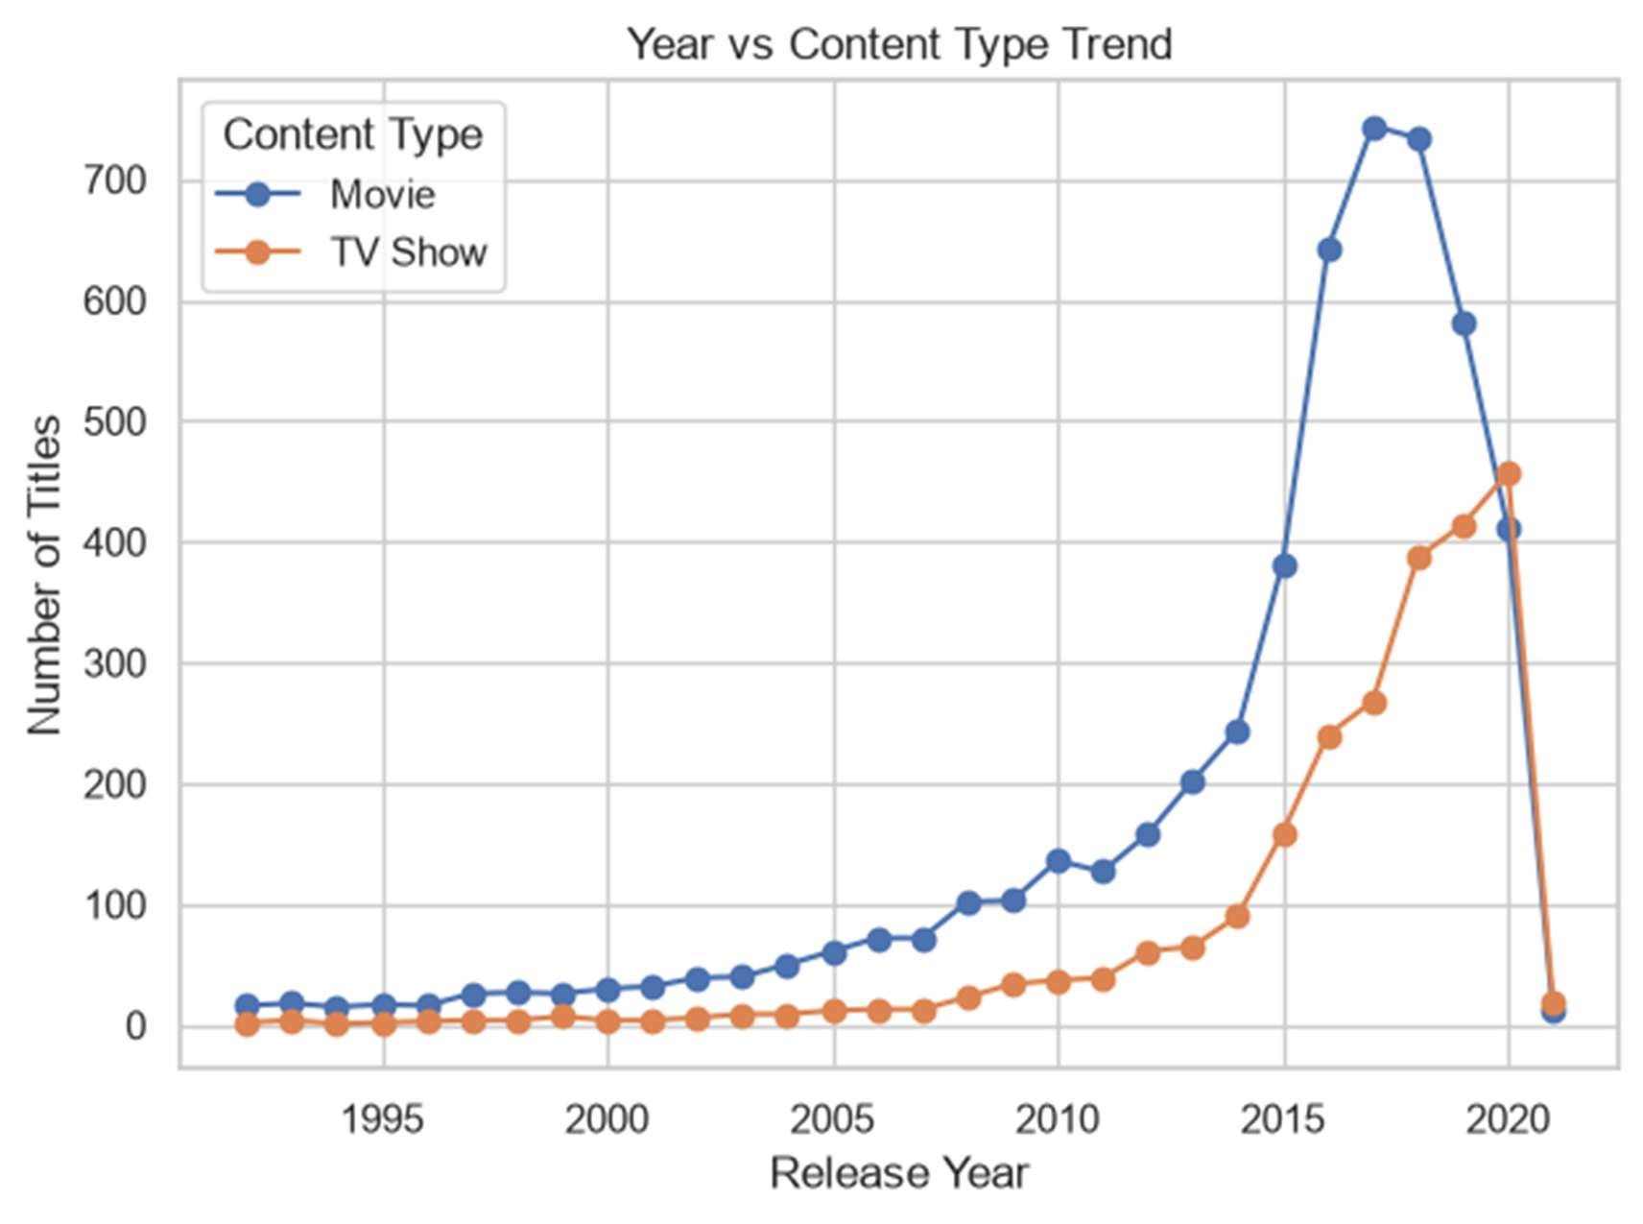
Figure 14: Year vs content type trend

Rating vs Content Type
rating | Movie | TV Show
TV-MA | 1850 | 1020
TV-14 | 1272 | 659
TV-PG | 505 | 301
R | 663 | 2
PG-13 | 386 | 0
TV-Y | 117 | 163
TV-Y7 | 95 | 176
PG | 247 | 0
TV-G | 111 | 83
NR | 79 | 5
G | 39 | 0
TV-Y7-FV | 5 | 1
UR | 5 | 0
NC-17 | 3 | 0

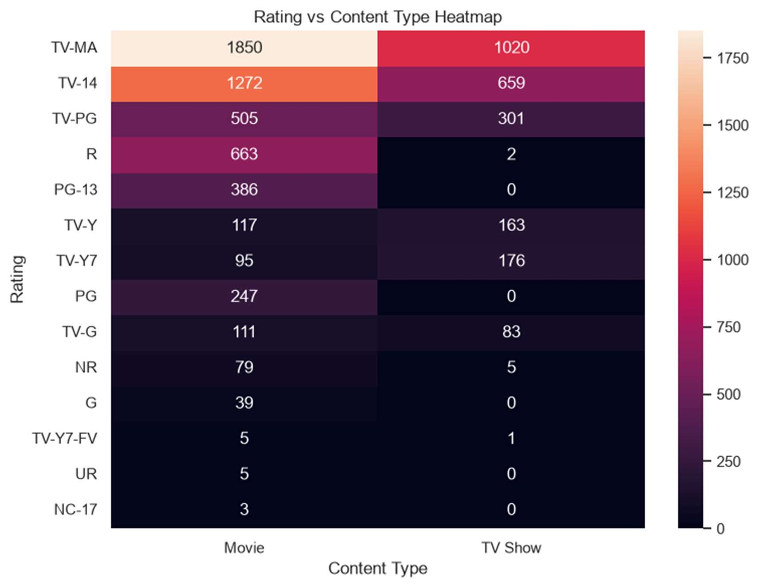
Figure 15: Rating vs content type heatmap
- United States leads in both movies and TV shows, while countries like Japan and South Korea show stronger TV Show presence compared with many other countries.
- Movies grew very fast up to 2018, while TV Shows became more competitive in 2019 and 2020.
- TV-MA and TV-14 dominate both Movies and TV Shows, showing a strong adult and teen-focused content strategy.

Task 12: Business Insights and Strategic Recommendations

5 Business Insights
- Movies dominate the platform: 5377 Movies (69.05%) compared with 2410 TV Shows (30.95%).
- United States produces the highest number of Netflix titles among known countries, with 3296 titles after splitting multicountry entries.
- Content production increased strongly up to 2018, where the dataset has 1121 titles.
- The most common maturity rating is TV-MA, showing strong focus on mature/adult audiences.
- The most popular genre category is International Movies. Medium-length movies are also very common with 3920 movies.

3 Strategic Recommendations
- Continue investing in international movies and dramas because these genres dominate the catalogue and support global audience reach.
- Increase local-language content from strong markets such as the United States, India, United Kingdom, Japan and South Korea.
- Balance the catalogue by adding more family-friendly and regional TV Show content while maintaining strong TV-MA and TV14 offerings for adult and teen audiences.

